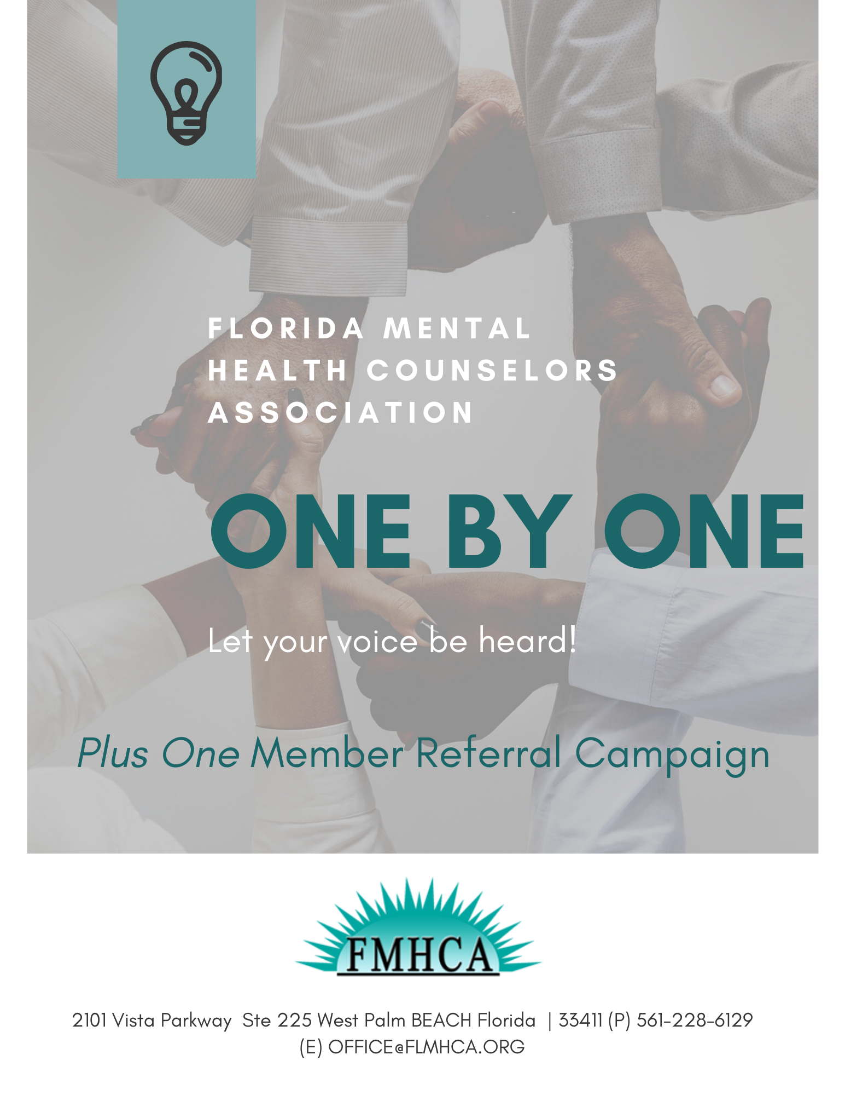

Join the FMHCA Plus One Campaign and Grow Our Collective Voice
For decades, the Florida Mental Health Counselors Association (FMHCA) has been built—one member at a time—into an inclusive and impactful community of over hundreds of members who support FMHCA's mission to advance the profession of clinical mental health counseling through intentional and strength-based advocacy, networking, professional development, legislative efforts, public education, and the promotion of positive mental health for our communities.
This spirit is driving FMHCA's new member referral campaign: Plus One.
Plus One lets you play an active role in building FMHCA's membership, and earn rewards for doing so.
How It Works
- Recruit at least 1 new member and receive a $15.00 credit applied to your FMHCA account to be used towards webinars, conferences, events, and membership.
- New Members will be prompted to input your name when completing the membership application.
- Once the application has been confirmed by the office staff the credit will be applied to your account.
Participation is easy.
Recruitment Toolkit:
Contains everything you need to participate in the campaign. Includes templates and graphics, tips for talking with prospective members, and other tools to make increasing our CommUNITY easy!
How to talk about the value of FMHCA membership:
FMHCA members are the association's greatest assets—and no one can promote the benefits of membership and offer a personal perspective better than you.
Plus One, FMHCA's membership-referral campaign, is your opportunity to share your successes, engage with your colleagues, and win prizes for yourself.
Below is information on how to hold conversations and how the campaign works. If you have questions or need additional help, please email office@FLMHCA.org. Thank you for your interest expanding the FMHCA community!

FIRST STEPS
Tell your story
Your FMHCA, chapter, and memberships provide a lot of value. Talk about the reasons you joined and why you remain a member. Think about what motivates you to ask others to join.
Ask questions
Focus on the needs of those you are contacting. Find out their specific concerns. Address them directly by citing your own experiences.
Think conversation
Think of this as a conversation—perhaps an ongoing one. Recruiting a member takes time. You may engage the individual in several conversations before he or she shows interest.
Make it easy
If a person sounds uncertain, he or she simply may not yet be ready to make a commitment. You want the individual to feel comfortable, so offer the FMHCA referral card with your information printed on it and the URL to join.
Say thanks
Be sure to say thanks. Write a short message thanking the individual for considering FMHCA membership and for supporting the Mental Health Counselor profession.
Tips
Try to avoid the word "why" when you're asking questions; it focuses on the past rather than the future.
For example, instead of asking, "Why don't you support FMHCA's advocacy efforts?" perhaps say, "Imagine if no one was speaking up for the profession of Mental Health Counselors in Tallahassee."

Templates
SAMPLE EMAILS OR LETTERS
Reach out to a colleague by copying and pasting this sample text below into a personal email. Before you click “send,” just remember to add your name and your FMHCA affiliated email address.
Enhancing or editing the message with your own story about why you joined FMHCA or the value of membership to you will have great impact. Feel free to add your personal touch.
Email/Letter 1
Dear [Name],
As you may know, I am a proud member of the Florida Mental Health Counselors Association (FMHCA). The FMHCA community was built 1 member at a time and is today an inclusive and impactful community of over hundreds of members who support the mission to “advance the profession of clinical mental health counseling through intentional and strength-based advocacy, networking, professional development, legislative efforts, public education, and the promotion of positive mental health for our communities."
I have found so much value in my FMHCA membership that I wanted to extend a personal invitation to you to join FMHCA. Members gain access to not only a community of professionals, but a variety of member benefits as well. Here are some of those benefits [Link to appropriate Member Perks list]. https://fmhca.wildapricot.org/page-1075383
If you join and enter my name [insert your Full Name affiliated with your FMHCA membership here]. Right wat you will have access to webinars and courses with CEUs for a full year. And, because you use my name and email, I will also be eligible to obtain a $15.00 credit towards a reward of my own choosing.
Join me and hundreds of other Mental Health Counselors professionals who benefit from FMHCA membership. Sign up online today.
Sincerely,
[insert your name]

Email/Letter 2
Dear [Name],
Are you familiar with the Florida Mental Health Counselors Association (FMHCA)? FMHCA is the largest professional organization in the state of Florida representing Mental Health Counselors. Today, alongside hundreds of members, FMHCA can carry out its mission to “advance the profession of clinical mental health counseling through intentional and strength-based advocacy, networking, professional development, legislative efforts, public education, and the promotion of positive mental health for our communities."
I have found so much value in my FMHCA membership that I wanted to extend a personal invitation to you to join FMHCA. Members gain access to not only to a community of professionals, but a variety of benefits as well. Here are some of those benefits [Link to appropriate Member Perks list]. https://fmhca.wildapricot.org/page-1075383
If you join and enter my name [insert your Full Name affiliated with your FMHCA membership here]. Right wat you will have access to webinars and courses with CEUs for a full year. And, because you use my name and email, I will also be eligible to obtain a $15.00 credit towards a reward of my own choosing.
It’s easy to join online by clicking here!
Please let me know if you have questions or would like any additional information.
Sincerely,
[insert your name]
Email/Letter 3
Dear [Name],
Membership in the Florida Mental Health Counselors Association (FMHCA) has been an invaluable resource for me in my professional career. I hope that you will consider joining so that you too have access to all FMHCA member benefits, including discounts, advocacy, professional resources, and a community of professionals who support one another to advance the profession to improve the mental health of our society.
It’s easy to join online by clicking here!
Thank you, and I hope you'll consider joining our growing community!
Sincerely,
[insert your name]

SOCIAL MEDIA POSTS & GRAPHICS
Note: Remember to insert @FMHCAtweets for Twitter or link to FMHCA's Facebook page (https://www.facebook.com/FloridaHealthCounselorsAssociation/) in place of "FMHCA" where appropriate. Hashtag your posts with #FMHCAMember and tailor for the platform you are posting to. Scroll down for social media graphics.
Example 1
My favorite FMHCA member perk is [insert your favorite perk] because [insert why you like this perk]. Join FMHCA and give my full name and you, too, can take advantage of [insert favorite perk]. #FMHCAMember
Example 2
The FMHCA community was built ONE by ONE—Be the next one. Join today, and give my full name! Let Your Voice Be Heard! #FMHCAMember
Example 3
FMHCA has hundreds of member members strong, and every member counts. Be 1 of the FMHCA community. Join today #FMHCAMember
Graphic 1
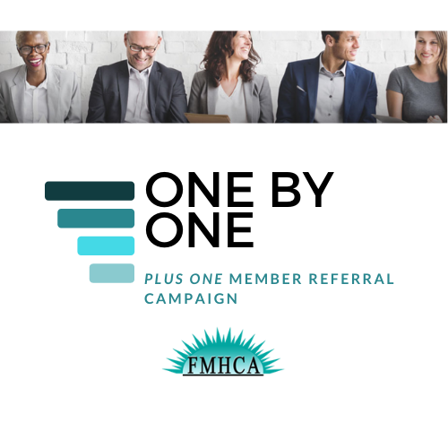

Graphic 2
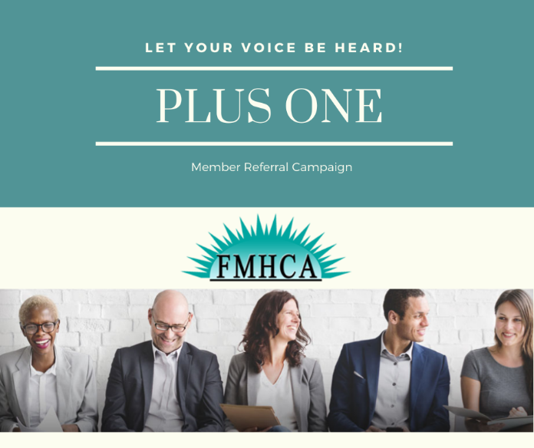

PLUS ONE COMPONENT ANNOUNCEMENT SAMPLE
Join the PLUS ONE Campaign and Grow Our Collective Voice
The Florida Mental Health Counselors Association (FMHCA) has been built—one member at a time—into an inclusive and impactful community of hundreds of members, who support FMHCA's mission to advance the profession of clinical mental health counseling through intentional and strength-based advocacy, networking, professional development, legislative efforts, public education, and the promotion of positive mental health for our communities. FMHCA's new member referral campaign Plus One allows you to play an active role in building FMHCA's membership and earn rewards for doing so.
Any current active FMHCA member is eligible to participate as a recruiter and eligible to obtain a $15.00 incentive. Encourage a new member to join FMHCA. To receive credit for each new or reinstated member recruited an online applications must reference the individual’s full name affiliated with the recruiting member's FMHCA membership. Applications without referring the member's full name cannot qualify toward an incentive.
Once a new member is on board, they are now also eligible to recruit others one by one and can be eligible to obtain the same $15.00 incentive!
For more information on full eligibility rules, email, and social media templates, Plus One referral cards that you can share with your colleagues, visit _________________.

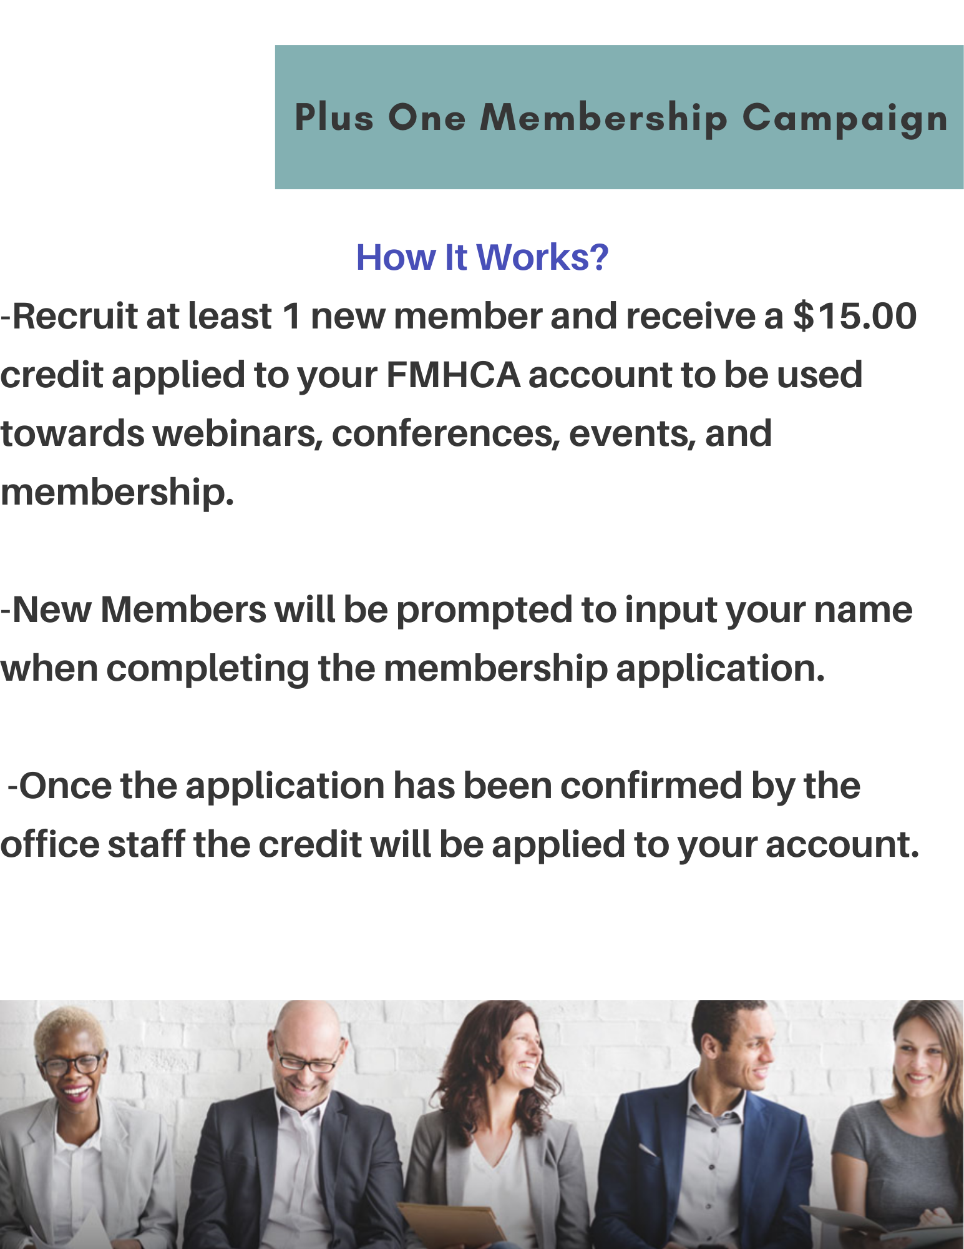

HELPFUL LINKS, TIPS, AND DOCUMENTS
Check to see who's a member.
Member Directory
Top 5 reasons to join FMHCA.
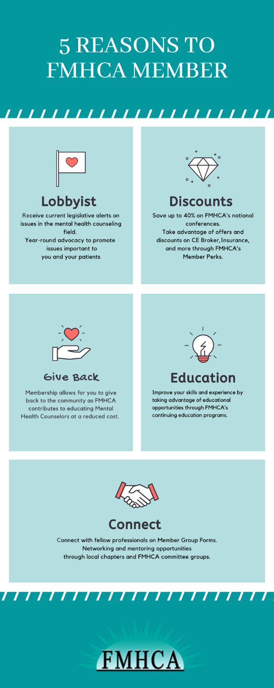

Share these cards with prospective members.
